Hands-on 5
JWT Authentication in ASP.NET Core Web API
Project: EmployeeWebApi
Objective: Configure JWT Bearer authentication, generate a JWT through the Auth endpoint, build and run EmployeeWebApi, and verify the result in Swagger.

1. Required Package
Ensure JWT Bearer authentication support is available in the project:
dotnet add package Microsoft.AspNetCore.Authentication.JwtBearer
Use a package version compatible with the target framework. The completed project shown in the screenshots targets .NET 10.

2. Program.cs
Configure controllers, Swagger, JWT authentication, authorization, and middleware as follows:
using Microsoft.AspNetCore.Authentication.JwtBearer;
using Microsoft.IdentityModel.Tokens;
using System.Text;
var builder = WebApplication.CreateBuilder(args);
builder.Services.AddControllers();
builder.Services.AddEndpointsApiExplorer();
builder.Services.AddSwaggerGen();
string securityKey = "mysuperdupersecretmysuperdupersecret";
var symmetricSecurityKey =
new SymmetricSecurityKey(Encoding.UTF8.GetBytes(securityKey));
builder.Services.AddAuthentication(options =>
{
options.DefaultAuthenticateScheme =
JwtBearerDefaults.AuthenticationScheme;
options.DefaultChallengeScheme =
JwtBearerDefaults.AuthenticationScheme;
})
.AddJwtBearer(options =>
{
options.TokenValidationParameters = new TokenValidationParameters
{
ValidateIssuer = true,
ValidateAudience = true,
ValidateLifetime = true,
ValidateIssuerSigningKey = true,
ValidIssuer = "mySystem",
ValidAudience = "myUsers",
IssuerSigningKey = symmetricSecurityKey
};
});
builder.Services.AddAuthorization();
var app = builder.Build();
if (app.Environment.IsDevelopment())
{
app.UseSwagger();
app.UseSwaggerUI();
}
app.UseHttpsRedirection();
app.UseAuthentication();
app.UseAuthorization();
app.MapControllers();
app.Run();

3. AuthController.cs
Create the Auth endpoint that signs and returns a JWT. The issuer, audience and signing key must match Program.cs.
using Microsoft.AspNetCore.Mvc;
using Microsoft.IdentityModel.Tokens;
using System.IdentityModel.Tokens.Jwt;
using System.Security.Claims;
using System.Text;
namespace EmployeeWebApi.Controllers
{
[Route("api/[controller]")]
[ApiController]
public class AuthController : ControllerBase
{
[HttpGet]
public IActionResult GetToken()
{
string securityKey =
"mysuperdupersecretmysuperdupersecret";
var symmetricSecurityKey =
new SymmetricSecurityKey(
Encoding.UTF8.GetBytes(securityKey));
var signingCredentials = new SigningCredentials(
symmetricSecurityKey,
SecurityAlgorithms.HmacSha256);
var claims = new List<Claim>
{
new Claim(ClaimTypes.Role, "Admin")
};
var token = new JwtSecurityToken(
issuer: "mySystem",
audience: "myUsers",
claims: claims,
expires: DateTime.Now.AddMinutes(30),
signingCredentials: signingCredentials);
return Ok(new JwtSecurityTokenHandler().WriteToken(token));
}
}
}

4. Securing an Employee Endpoint
Where the hands-on requires protection, add the authorization namespace and [Authorize] to the relevant controller/action while keeping its existing employee logic.
using Microsoft.AspNetCore.Authorization;
[Authorize]
[HttpGet]
public IActionResult Get()
{
// Keep the existing employee retrieval logic here.
return Ok();
}

5. Build
Save the files and build:
dotnet build
Expected result: Build succeeded. If EmployeeWebApi.exe is locked by an earlier running instance, terminate that process and build again:
taskkill /PID <process-id> /F
dotnet build

6. Run the API
dotnet run
In the completed run, the application started successfully and listened on http://localhost:5027.
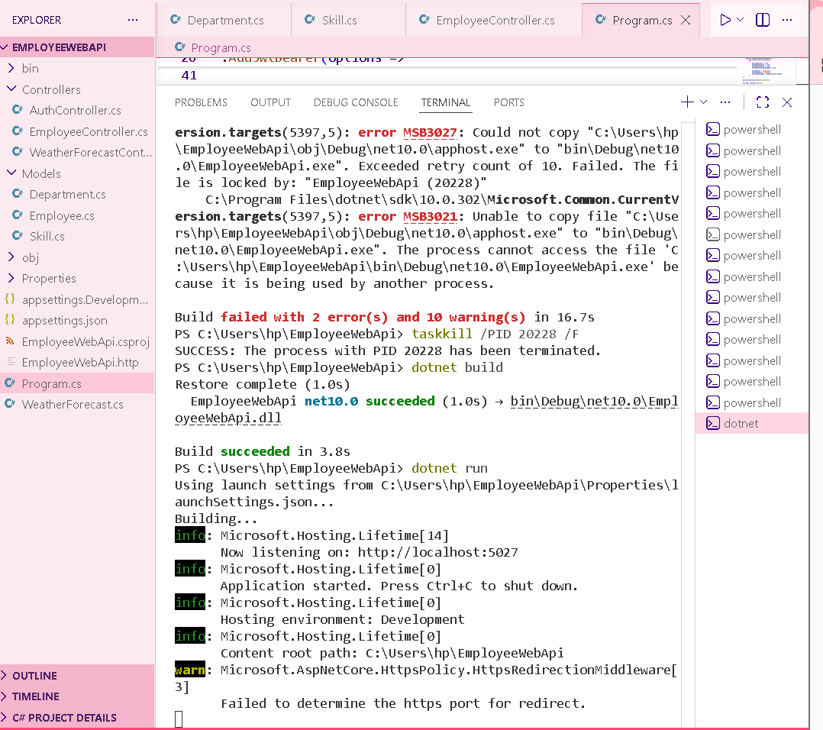
Figure 1: Successful build and dotnet run; EmployeeWebApi is listening on port 5027.

7. Execute GET /api/Auth in Swagger
Open the Swagger page using the port shown by dotnet run. For this run: http://localhost:5027/swagger/index.html. Expand GET /api/Auth, choose Try it out, then Execute.
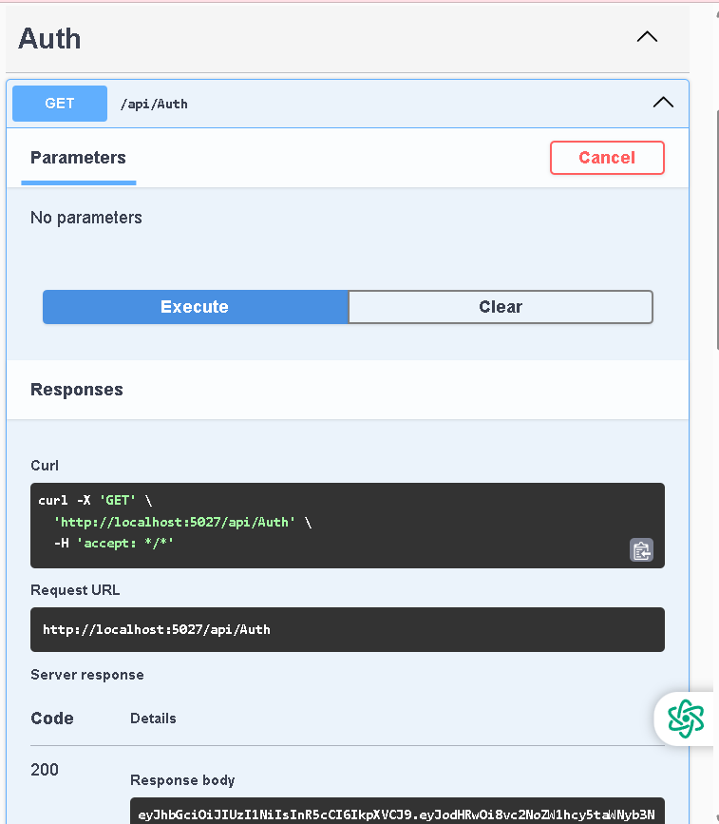
Figure 2: GET /api/Auth executed in Swagger.

8. Verify the Result
The server returns HTTP 200 OK. The Response body contains the generated JWT token.
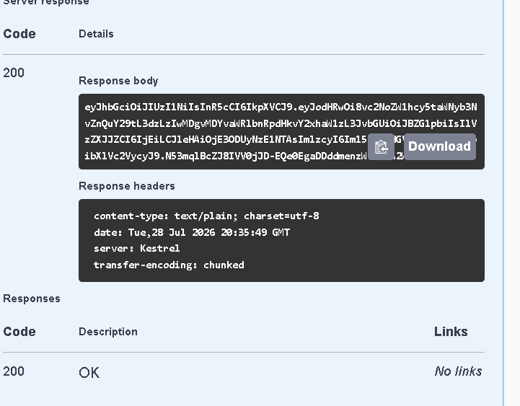
Figure 3: HTTP 200 response containing the generated JWT token.

9. Result
JWT Bearer authentication was configured successfully. EmployeeWebApi builds and runs, GET /api/Auth executes successfully in Swagger, and a JWT token is returned with HTTP 200 OK.

